BREATHING SYSTEM CONDITIONING PARAMETERS
SPONSOR:
CONTACT:
SAMPLE ID:

INTENDED USE -

Adult Pediatric

CONDITIONING POSITION - See diagram below.

A B C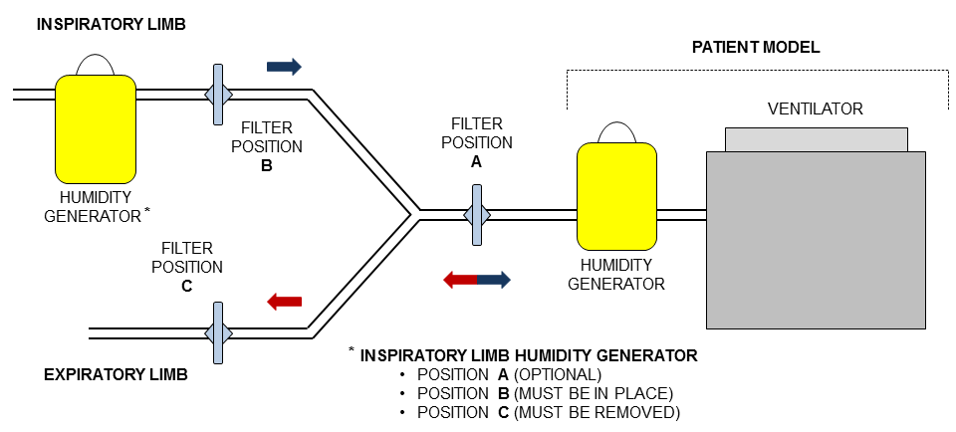INSPIRATORY LIMB HUMIDITY GENERATOR ( applies to position A only)

For Position A please mark: Removed In Place (Not Removed)

Note: for Position B “must be in place” and for Position C “must be removed” will be performed.

TEST SIDE (Side that will face the patient model during conditioning and be impacted by NaCl during NaCl testing)-

SMALLER PORT LARGER PORT OTHER: .

NUMBER TO BE TESTED -
Conditioned: |  | Not Conditioned: |  |  |  | Total:
SIGNATURE: |  |  |  | DATE:

Confidential and Proprietary Information. Do not duplicate or copy.

